Administration of Podolsk
The Committee of Education
Secondary school No17
T.r. Podolsk, Moscow region,
Vysotnaya Street, 17

Report:
“SLANG IN MODERN ENGLISH MUSIC”

The work done
by Guliev Akim,
11 "A" form, secondary school No. 17
Teacher Pechckurova Elena Anatolyevna

T.r. Podolsk, 2020
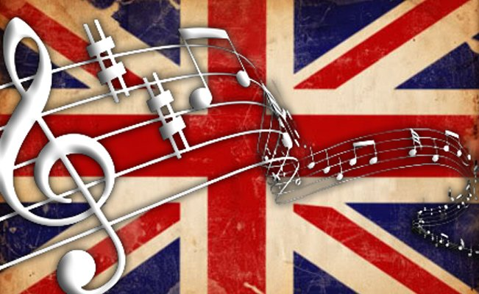
“Slang is a language that rolls up its sleeves, spits on its hands and goes to work”
-Carl Sandburg

- Music occupies an important place in our life. We can’t live without it. People have different musical tastes depending on their age, education and even mood. Most of us listen to music, but not everybody really understands it because many musicians use a lot of slang words, phrases and grammar mistakes. I’ve noticed that most adults cannot understand slang, even though they think it’s rather simple. They say “How can it be hard, if, except for musicians, it’s used only by kids these days?” The truth is that it can be. So, I’m going to tell you about slang in modern music and hopefully we can learn something new.
It’s known that most subculture groups could be identified with a specific music genre and in some instances music was the defining characteristic around which the group was formed. In other communities music is a key feature. There are several reasons and benefits in knowing the appropriate slang or terminology in music in our days.
Firstly, it’s the most assured way for you to connect with your peers and “speak the same language” a.k.a. vibe on the same frequency.
Secondly, and this is true to any professional field, by taking time to study the terminology you will expand your knowledge of your craft and will be able to internalize the technical and creative aspects in greater depth.
Moreover, each subculture inevitably acquires its own professional language and jargon. This is because new aspects appear in a separate linguistic space-from borrowing from other languages to the birth of new trends. Here is a selection of English words and expressions used by musicians and the most advanced fans.
The word #1 – guap.
Basically, the word ‘guap’ means a lot of money and it stands for a dollar banknote that has a photo of George Washington. With that being said, the very first form of ‘guap’ was ‘gwop’, which is an abbreviation for ‘George Washington On Paper’. This word is pretty popular in music and here is the example from one of the famous rap songs:
“They wonder how - how I guap like that” (As you can see, guap can also be a verb, which means ‘to make a lot of money’).
The word #2 – ain’t.
As you may already know, ain’t is a negative variation of the verb ‘to be’. In fact, this is a really old one – its first appearance was in 1695 in William Congreve’s play. Even though, ain’t is still really popular and can be heard in 90% of modern songs. For example:
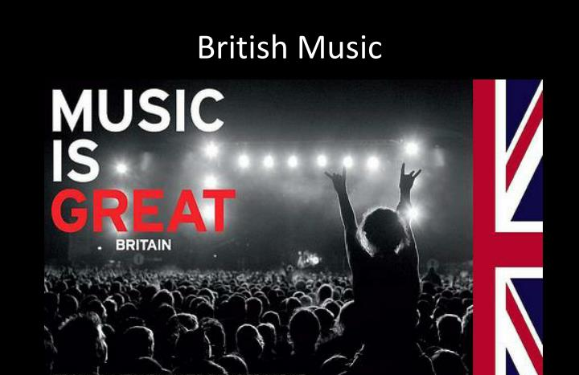
“You ain’t got no life”; “It ain’t no deals”; “I ain’t never asked no one for help”.
What is more interesting is the fact that each of these examples has a grammar mistake such as double negation, which is mostly used with ain’t. And since I’ve mentioned grammar mistakes, let’s get right into them.
Mistake #1 – Incorrect tense formations.
You can hear them in almost every rap song. To be honest, a lot of musicians just forget about grammar rules. For instance:
“I done did” instead of “I have done” or “She don’t care if I die” instead of “She won’t care…”
Mistake #2 – Getting rid of the verb ‘to be’.
That’s a popular one and as a musician myself I think this mistake exists only because sometimes ‘to be’ doesn’t really fit in the lyrics.
The example from music is:
“How we gonna make it?” instead of the right version, which is “How we are going to…”

And if you still think slang is quite easy to understand, let me tell you this:
- “whip” means a car;
- “ice” means brilliants (for instance you can often hear some phrases such as “Ice on my neck” in rap music);
- “very cool” can be replaced by “lit”, “ballin’” or “off the chain”;
- “money” can be said as “racks”, “cash”, “dough”, “bacon” and so on.

So, slang is a result of the changes in culture. The interest of young people mostly goes to much newer music, which is strongly related to slang. Although, older people believe that such words and phrases are not important. Needless to say that they help musicians to send the song messages more clearly. And most importantly, they create the connection between fans and their idols.

Список литературы
1 Aleshinskaya E. Key components of musical discourse analysis // Research in Language. 2017. Vol. 11(4). P. 423–444
2. Максимова Т. В. Современные тенденции развития сокращения как способа словообразования в английском языке // Вестник Волгоградского государственного университета. 2013, № 3 - С.85-91 Режим доступа:
http://cyberleninka.ru/article/n/sovremennye-tendentsii-razvitiya-sokrascheniya-kak-sposoba-slovoobrazovaniya-v-angliyskom-yazyke
Электронный ресурс.
3 http://www.azlyrics.com
4 http://www.lyrics.com
5 http://www.native-english.ru
Yandex.ru: Яндекс картинки: https://yandex.ru/images/search?text=%D1%84%D0%BE%D1%82%D0%BE%20modern%20english%20music&lr=10747

